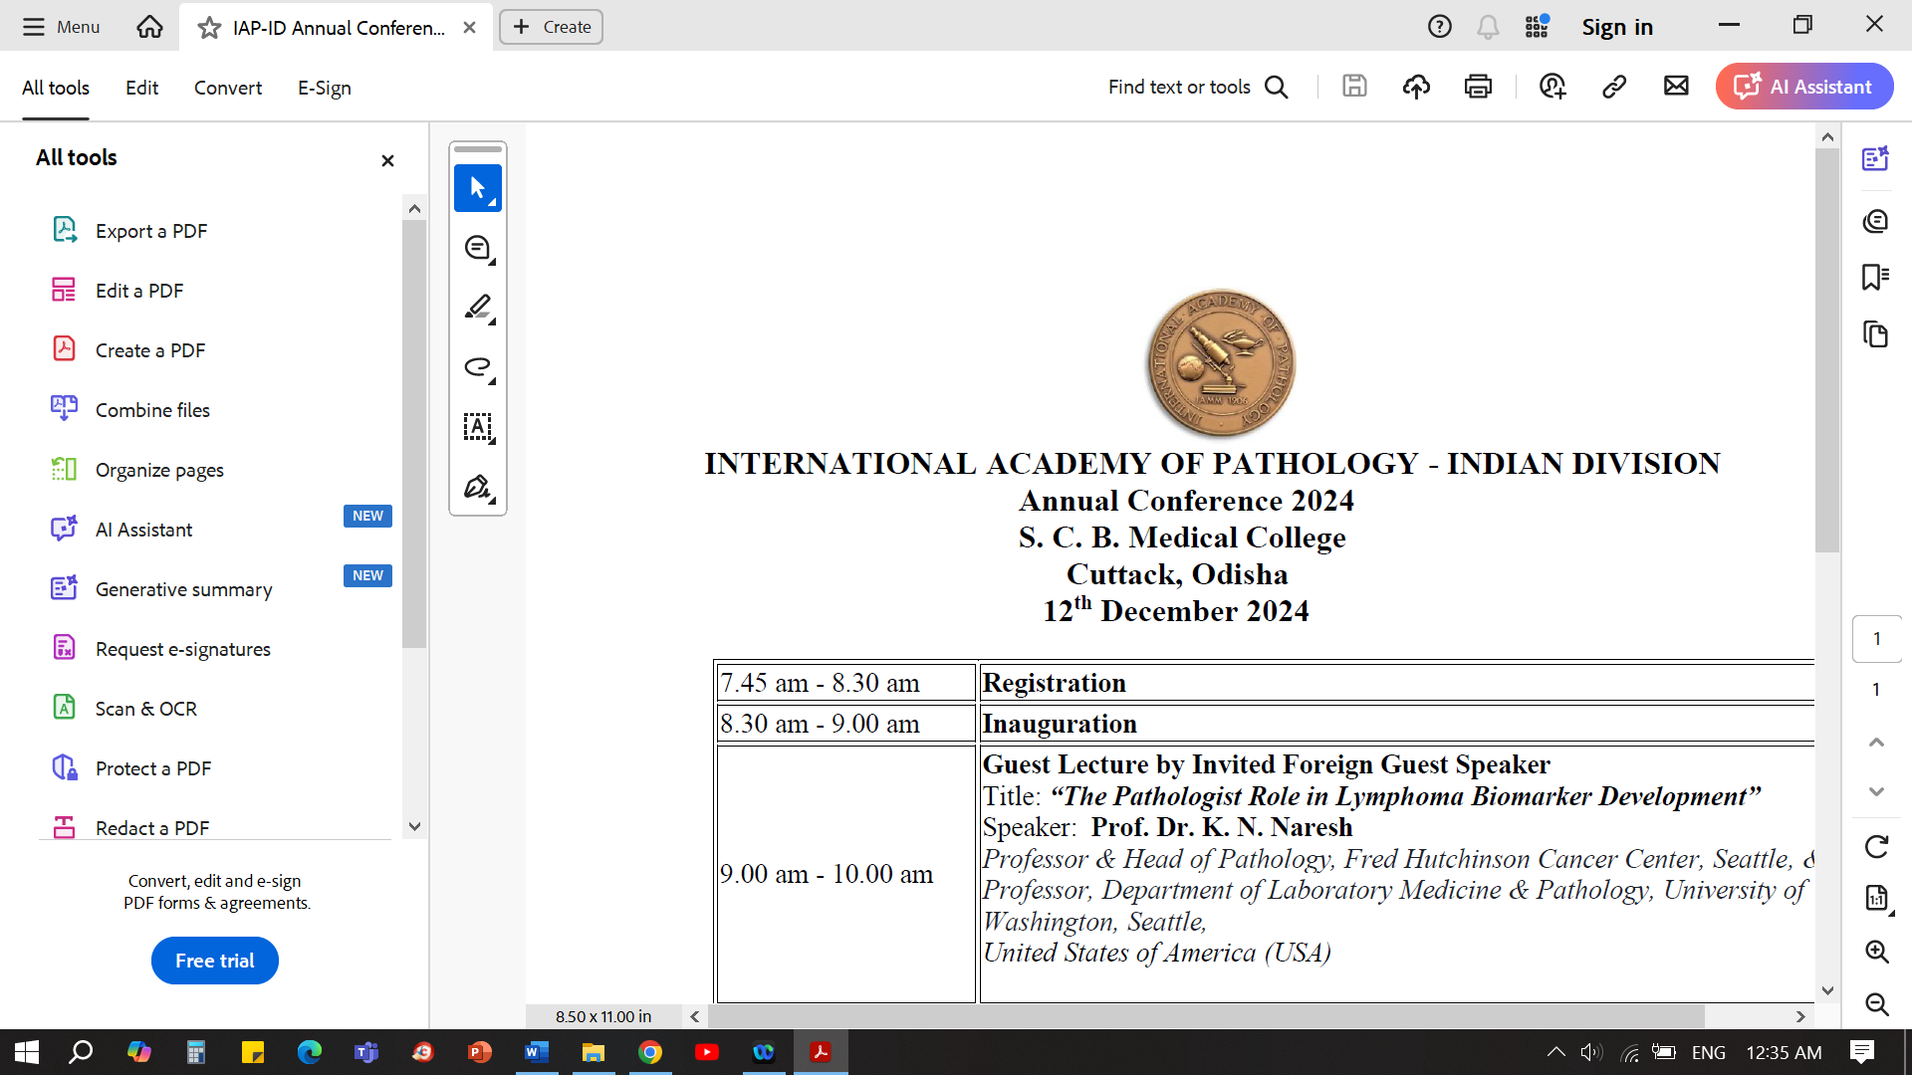

**Slide seminar programme**

**[**10.30-12.30 pm ]

**Topic: The Mighty Little Vermiform Appendix: Its Pathology and Frontiers**

Moderator: Dr. Usha Kini, Bengaluru

**Introduction :** Dr Usha Kini, Bengaluru

**Part 1:** " And Lo! the Mighty Appendix in Little Adults"

Dr Usha Kini, Bengaluru

**Part 2:** "The little Devil and it's Bag of Tricks"

Dr K P Aravindan, Calicut

**Part 3 :** ”Mucinous maladies to peritoneal pandemonium - the hidden dangers of

appendix tumours”

Dr Paromita Roy, Kolkota

**Closing remarks:** Dr Usha Kini, Bengaluru

**Q & A**

- XXXX-